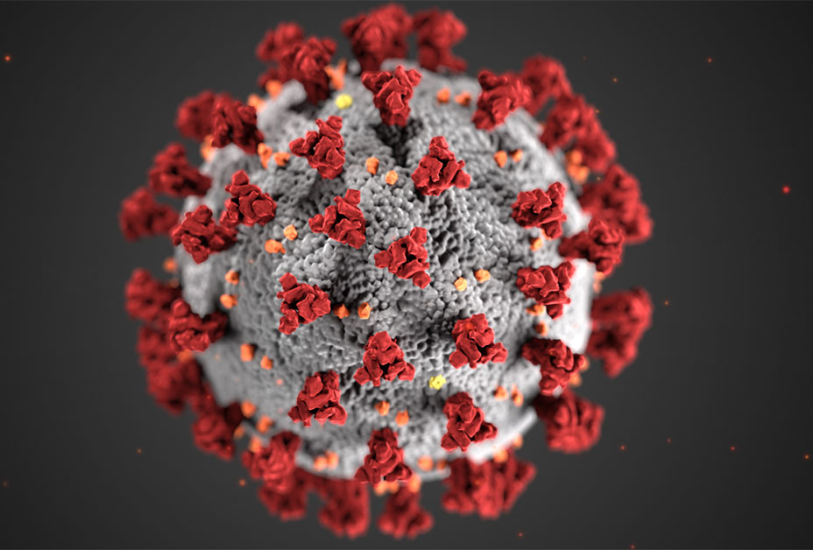

Novel Corona Virus 2019
Rohan Naga Venkata Mayukh Ungarala
016000127
Department of Applied Data Science, San Jose State University
Data 230: Data Visualization
Under guidance of Professor Andrew H. Bond
December 11, 2022

Table of Contents
Table of Contents 2

Abstract 3

Project Goals and Motivation 4

Objectives 5

Data Description 6

Data Collection and Preparation 7

Challenges Faced 13

Deliverables 14

Scope of Work 15

Charts 16

Horizontal Bar Chart 16
Treemaps 18
Packed Bubbles 20
Summary of Global Covid – 19 of the entire world 22
Summary of Global Covid – 19 of the entire world 23
TreeMaps for confirmed cases in India 24
Vertical bars representing the deaths in states of India 25
Horizontal bars representing the recovered cases in India 26

Dashboards 27

Conclusion 29

Future Scope 30
References 31

Github ID: https://github.com/RohanUngarala/Data-Visualization

Abstract
Covid was the most common term, and it was like a part of everyone's life from the year 2020, which was a challenging time for everyone in the world. The pandemic has affected the entire globe in all factors. During this pandemic, the whole world's governments suffered a lot. In this challenging time, data played a vital role in different ways. It helped in predicting the intensity of cases in numbers, which led to developing the vaccine and controlling the infectious disease. The analysis of the disease helped governments to initiate measures like complete lockdown, compulsory wearing a mask, many sanitization techniques, etc. In this project, we will look into various insights like total confirmed, and recovered cases in different nations, confirmed and recovered instances in India, the highest and least death rates worldwide, forecast Trend-Line for COVID - 19, can we group Indian states and find COVID - 19 Hits?, find the variation in COVID - 19 Cases around the world find the Highest Death rates in International Level, can we forecast the sheet for future and reference. The data was collected from Kaggle. Using the data, we will do valuable visualizations in Tableau Desktop and Tableau Prep and derive helpful conclusions.

Project Goals and Motivation
The pandemic's effects are more than enough of a reason to choose this topic. This project's objective was to examine the COVID-19-related material and reach useful conclusions. In order to accomplish that, the dashboard was divided into several sections. A dashboard was created to display the most recent data on COVID cases with respect to the various continents and nations. Additionally, dashboards that are interactive will be created to show the trend of cases reported, people recovering, and deaths.

Objectives
- The total number of nations affected by COVID.
- The total number of confirmed cases reported, deaths, and recovered cases worldwide.
- The total number of Confirmed cases, deaths and recovered cases reported in India.
- Geological maps that project the volume of reported cases.
- Trend analysis of cases reported, people who recovered, and fatalities in each nation with a date filter.
- The proportion of each continent in the world that reports cases, recovers, dies, and undergoes testing.
- Forecast of Covid – 19 presences for future and reference.

Data Description
Several datasets about the COVID-19 are publicly accessible. John Hopkins was the first organization to begin gathering information about the virus, such as the number of cases broken down by geographic region. However, as this problem developed into a pandemic, a number of organizations, including the World Health Organization (WHO) and governments, began maintaining virus data. Governments can use this information in a variety of ways to help them decide how best to deal with the virus. Data was downloaded during that process from the Kaggele, which had access to the John Hopkins repository, where it had been updated. Data in CSV format was downloaded from Kaggle.
There are 10 columns and 2,05,951 rows in the dataset. However, we will only focus on the columns that are essential for analysis. The dataset columns that were used in this project are described as below. Following are the columns of the datasets:
Main file in this dataset is covid_19_data.csv and the detailed descriptions are below.
covid_19_data.csv
- Sno - Serial number
- ObservationDate - Date of the observation in MM/DD/YYYY
- Province/State - Province or state of the observation (Could be empty when missing)
- Country/Region - Country of observation
- Last Update - Time in UTC at which the row is updated for the given province or country. (Not standardised and so please clean before using it)
- Confirmed - Cumulative number of confirmed cases till that date
- Deaths - Cumulative number of deaths till that date
- Recovered - Cumulative number of recovered cases till that date

Data Collection and Preparation
Figure 1
Sample of the raw dataset
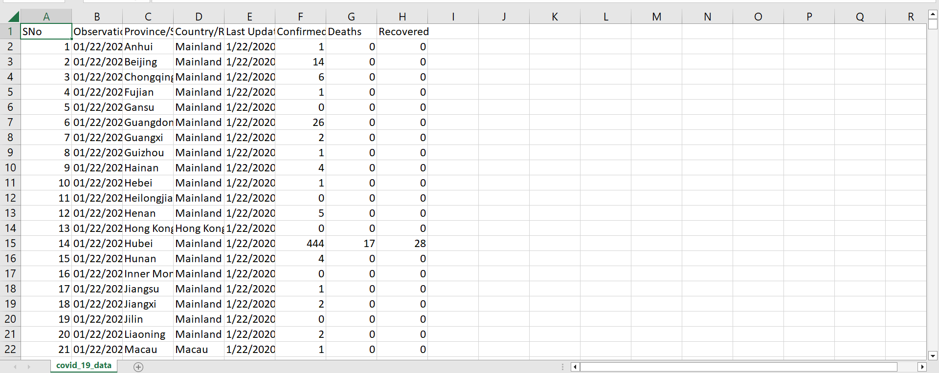
This is the raw dataset of the project that is the Covid -19 of the entire world. The dataset was taken from the Kaggle.
Figure 2
Connecting the dataset to the Tableau
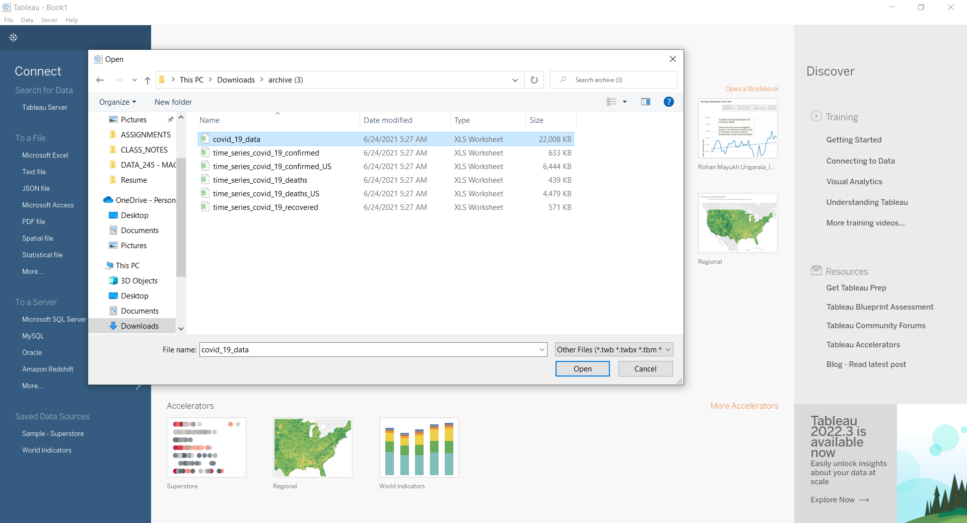
Open the Tableau Desktop and in connect select the more option from that select the desired dataset file and click open. The same is shown in figure 2.
Figure 3
Dataset connected with the Tableau
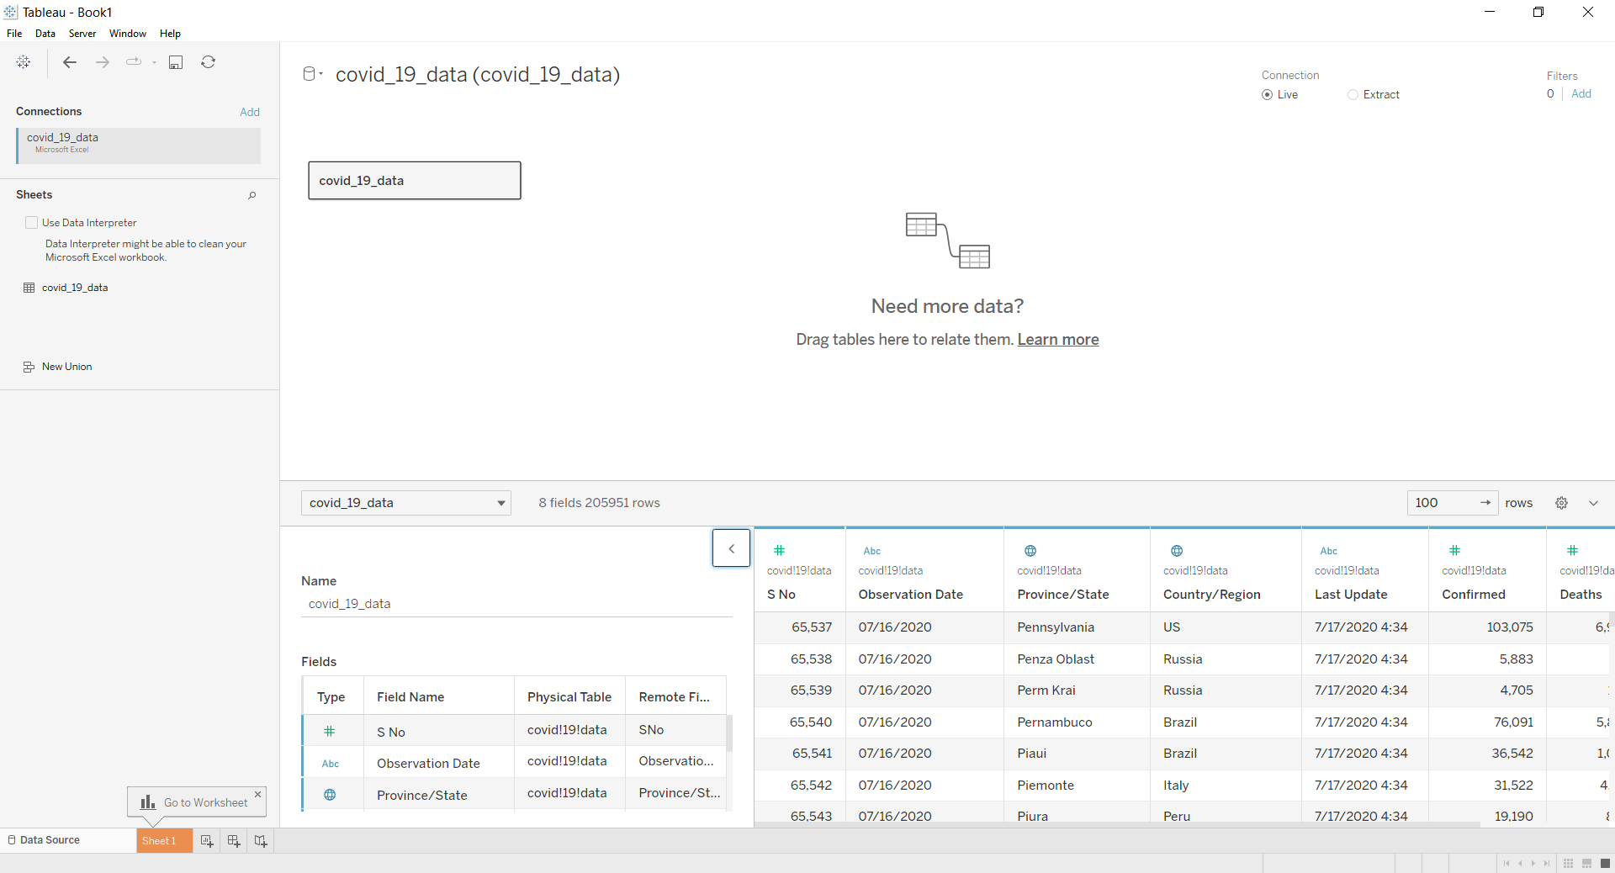
After the dataset was connected to the Tableau, the data might have some noisy/messy data which the Tableau identifies and prompts the use of “Data Interpreter” which was illustrated in figure 3 and click the check box so that data will be cleaned.
Figure 4
Data interpreter cleaning the data
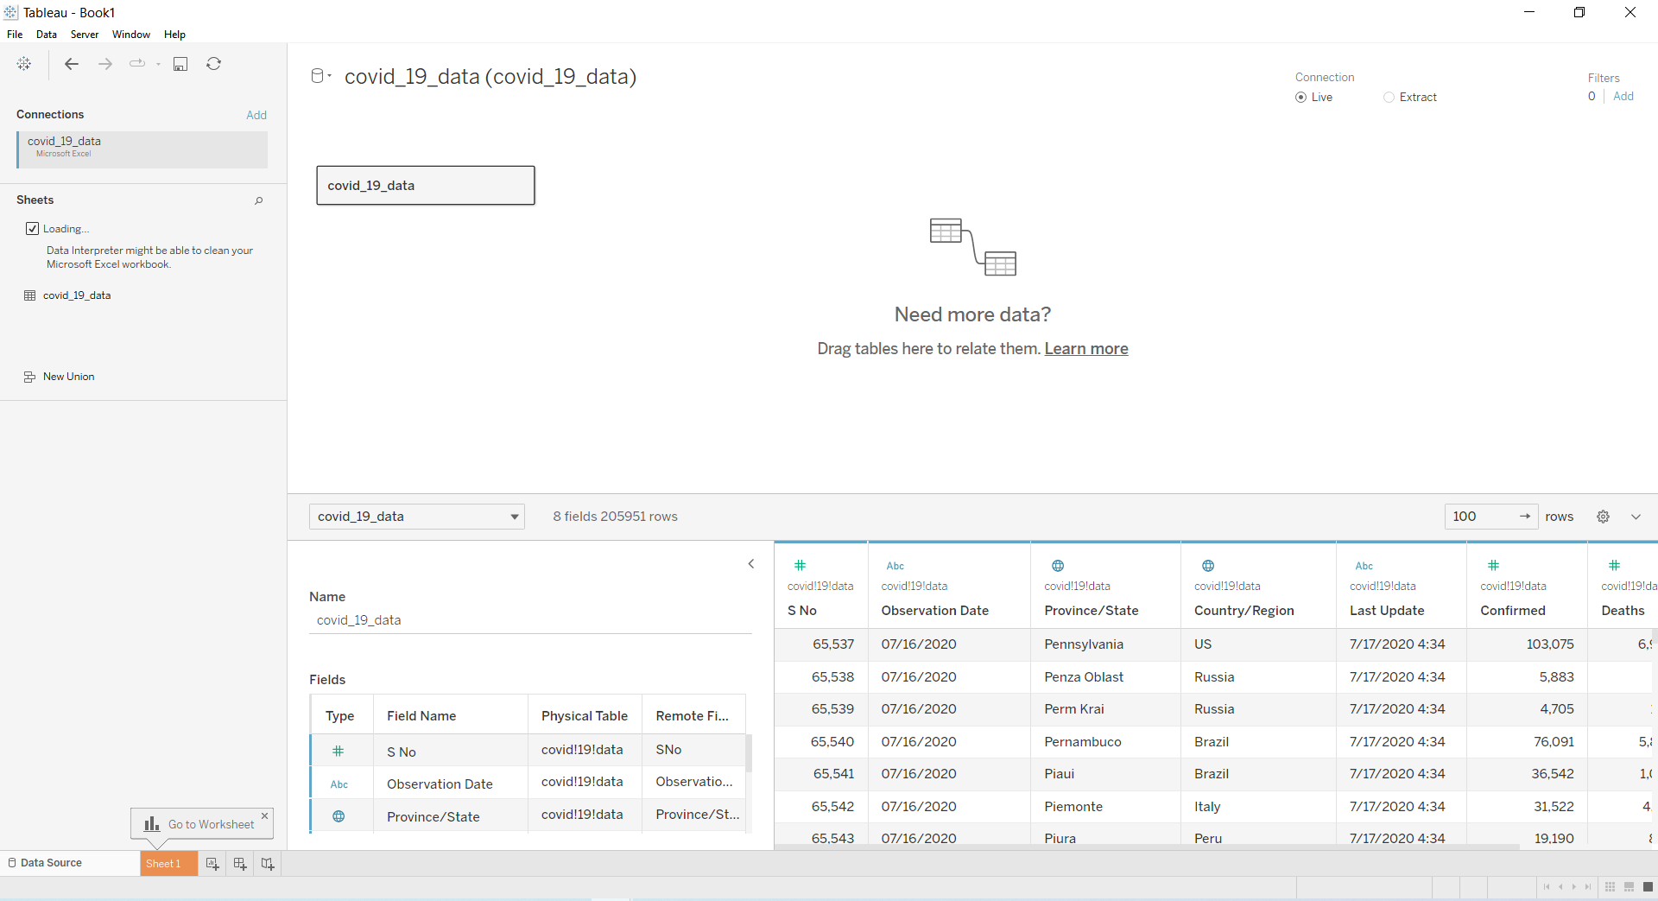
From the figure 4, we can observe that the data was getting cleaned by the data interpreter it will take some time based on the size of the data.
Figure 5
After data cleaned by the data interpreter
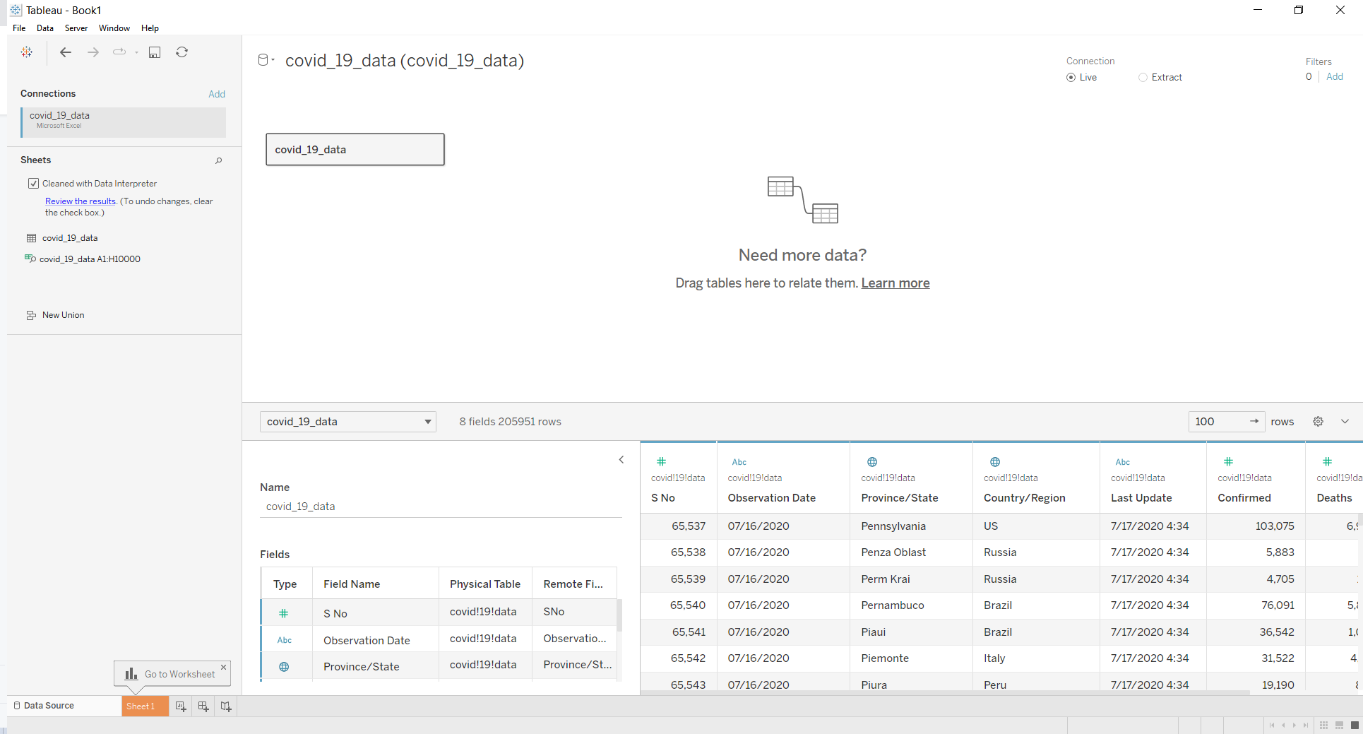
Once the cleaning process was done, we will get the message as displayed in figure 5 that “Data is cleaned” and also, we can check the result by clicking the “review the results”.
Figure 6
Legend for understanding the data interpreter results
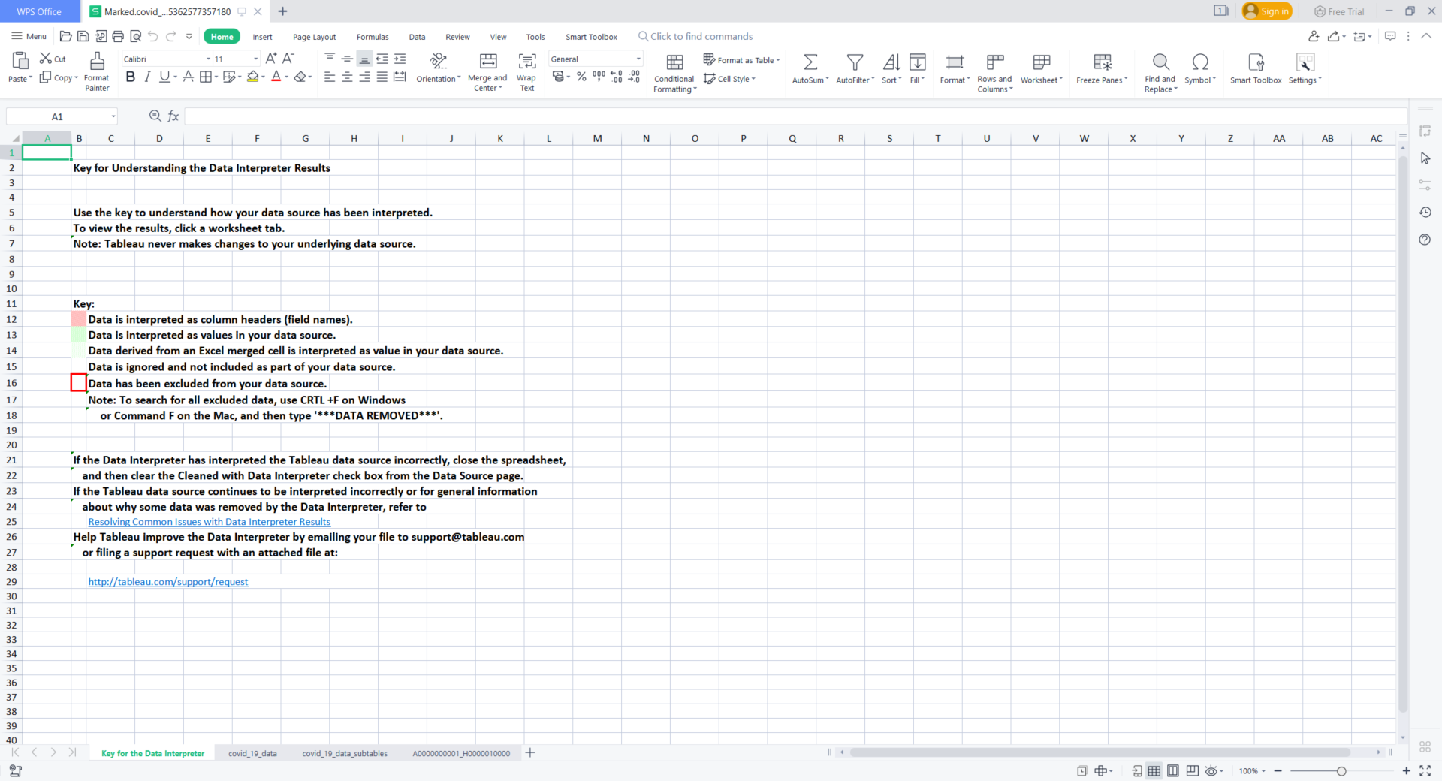
As mentioned above from figure5, after clicking the link we will get the prompt and gets opened as shown in figure 6, it shows the legend for understanding the data interpreter results which mentioned about how the data was interpreted.

Figure 7
Exploring the Data Interpreter results
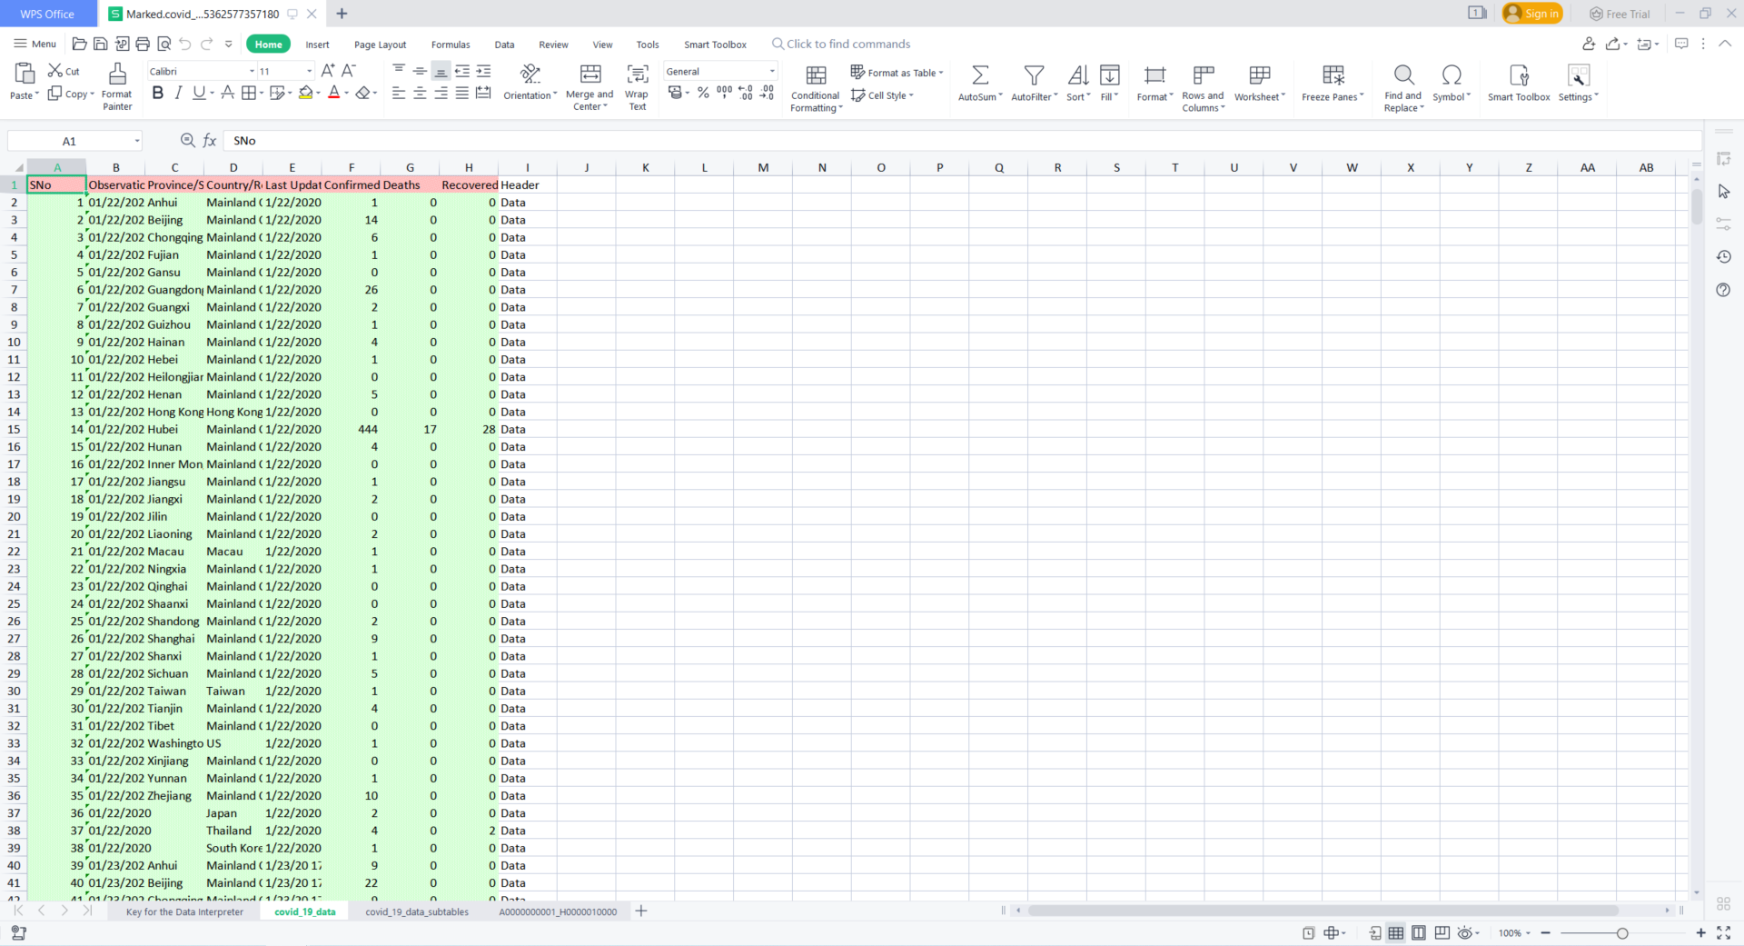
Figure 7 illustrates the data from which the data was interpreted by the interpreter and displaying the data as per the legend.

Figure 8
Dataflow process from the dataset to Tableau
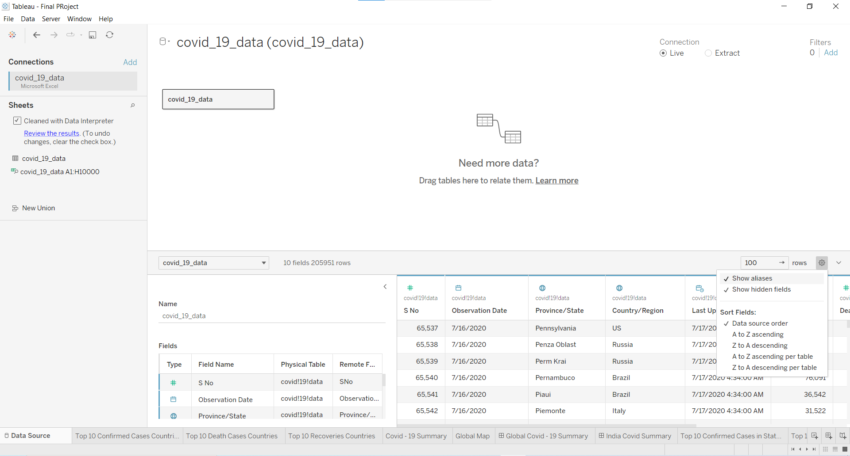
After the data interpretation so we will get the final cleaned dataset, as shown in figure 8 the columns present in the dataset were displayed and two other options are selected that are “show aliases” and “show hidden fields”.

Challenges Faced
It has taken a long time to gather the data and to comprehend the data. Dealing with the null values has been time-consuming due to the large number of null values in the dataset. Understanding medical terms and statistics was a little difficult because the subject is tied to a health-related issue.

Deliverables
The creation of two key dashboards for comprehensive distributed analysis is the project's most significant deliverable. Additionally, a project presentation is made. And a report on the Final Project will be delivered. All the data processing and visualization codes will be provided.

Scope of work
Since the WHO provides the health status to entire nations, but it is much focused on the developing nations and the geo data does not consist of all the countries in the world. There were no details of the states of those countries where the cases have been conducted.

Charts
- Horizontal Bar chart
Figure 9
About the horizontal bars
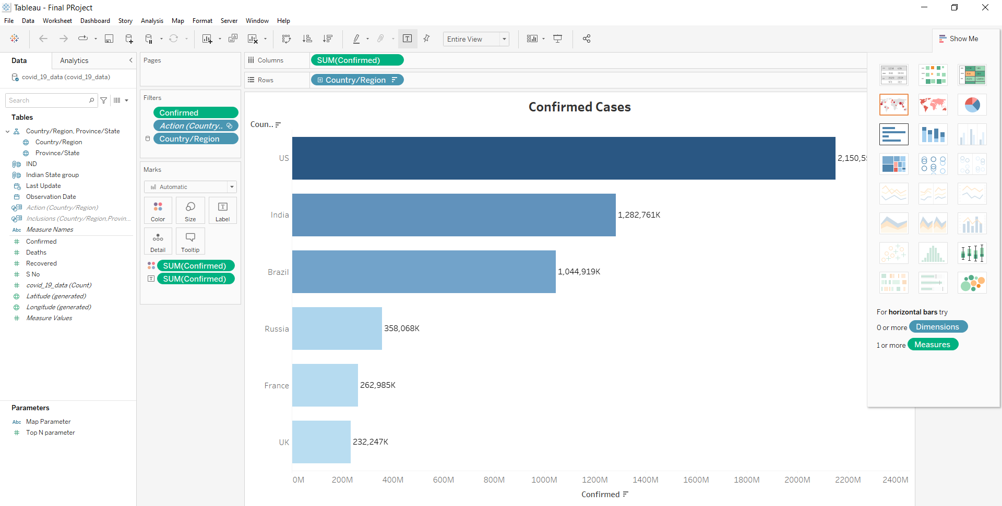
In a bar chart, data is shown as rectangular bars with lengths that are inversely correlated with the values of the variables. When you drag a dimension to the Row shelf and a measure to the Column shelf in Tableau, a bar chart is automatically generated. This option will automatically become grayed out if the data is not appropriate for a bar chart. The Bar mark type is used in bar charts. When the data view matches the field arrangements depicted in figure 10, Tableau chooses this mark type. To these shelves, additional fields can be added. Finally, the dimensions zero or more are required and one or more measures are required to form horizontal/ vertical bar chart.

Figure 10
Horizontal Bar Chart representing the confirmed cases of top 6 nations in the world
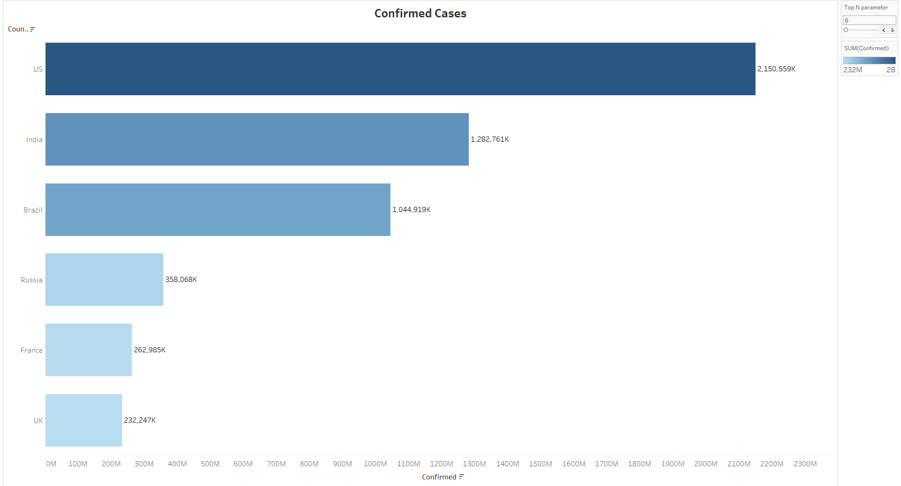
The figure 10 displays the horizontal bar chart, for where it displays the top six countries of the world where the “Top N parameter” is set to six we can change the value by moving the slider. The X – axis was represented for the number of cases and the Y-axis was represented for the countries in the entire world. From the figure 10, we can observe that the highest confirmed cases are from the United States with 2,150,559K cases then followed by the India with 1,282,761K cases and the final one was the UK with the 232,247K cases.

- Treemaps
Figure 11
About treemaps
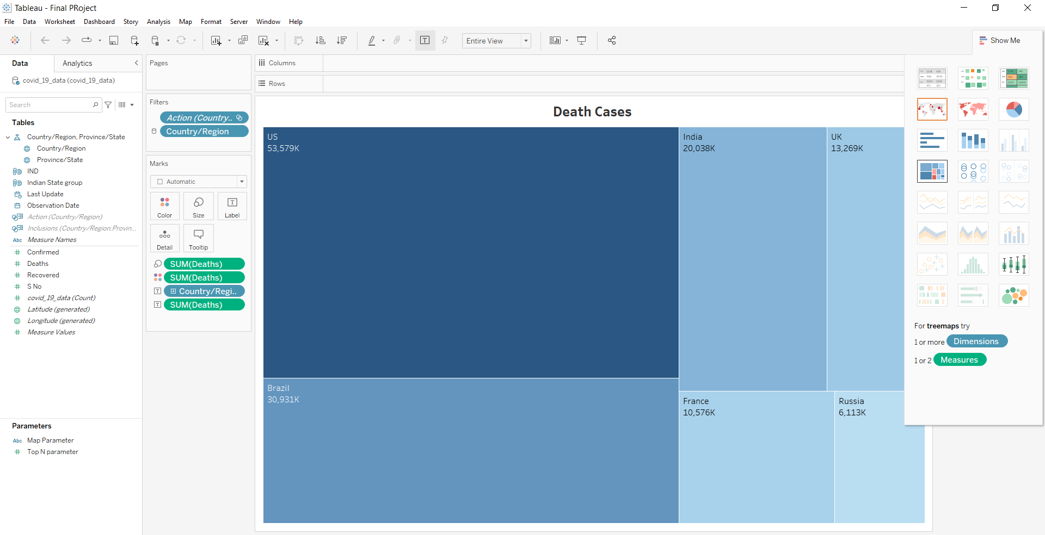
To display data as nested rectangles, use treemaps. The treemap's structure is defined by its dimensions, and each rectangle's size or color is specified by its measurements as shown in Figure 11. Treemaps are a straightforward data visualization technique that can present information in a visually appealing manner. With the help of treemaps, viewers can quickly and easily interpret their data. Dimensions (such as categories) or measurements can be represented by color (such as KPIs). If a KPI is being represented, a darker color may draw attention to extremes, either high or low. A user may use a categorical palette for dimensions, designating a different color for each shipping option. A continuous color palette for measures would display a business's sales figures or profit.
The largest box displays the largest portion of the whole, and the smallest box displays the smallest portion, when looking for insights in a tree map. For more in-depth analysis, to display multiple categories, these boxes may be nested. The treemaps should have one or more dimensions and one or two measures to form a treemap or else it will automatically grayed out as shown in figure 11.
Figure 12
Treemap representing the death cases of top 6 nations in the world
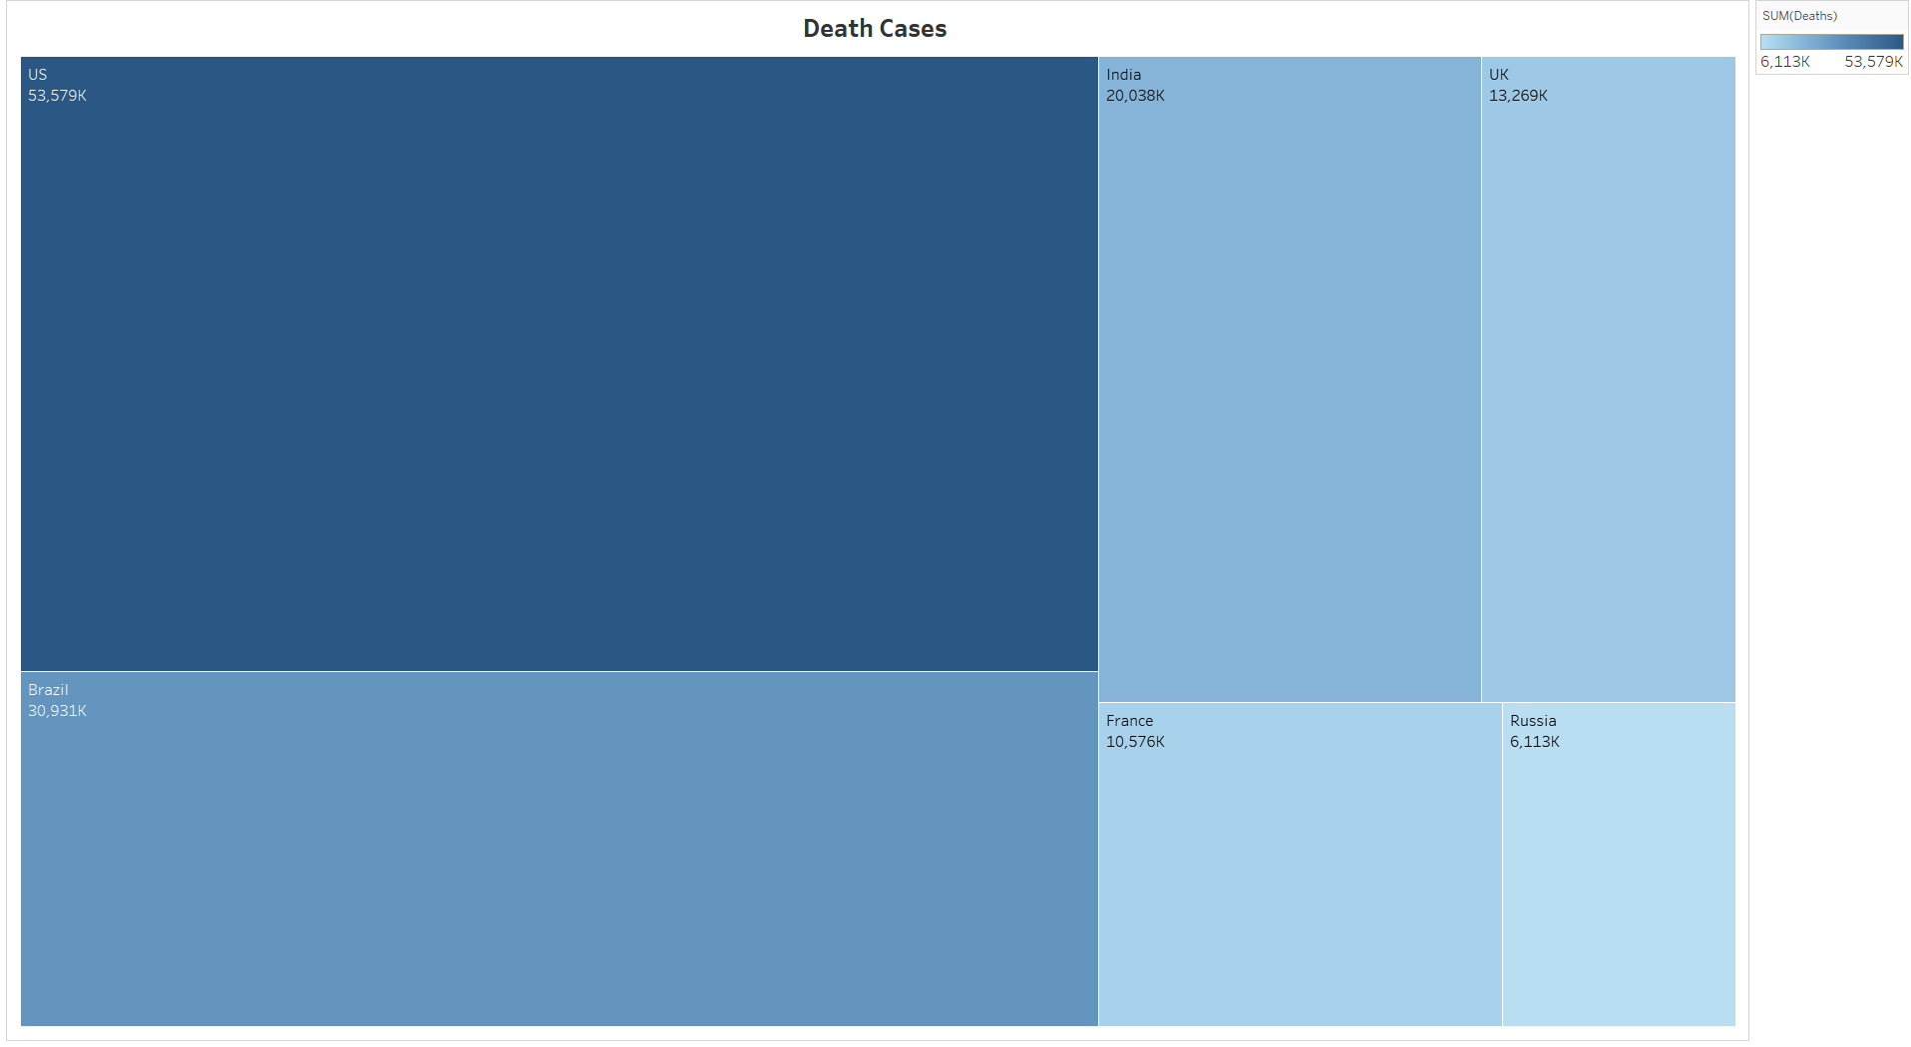

The figure 12 displays the treemap, for where it displays the deaths of top 6 nations in the world. From the figure 12, we can observe that the highest deaths cases by the color and measurement of the rectangular box that was from the United States with 53,575K cases then followed by the Brazil with 30,931K cases and the final one was the Russia with the 6,113K cases.
- Packed Bubbles
Figure 13
About packed bubbles
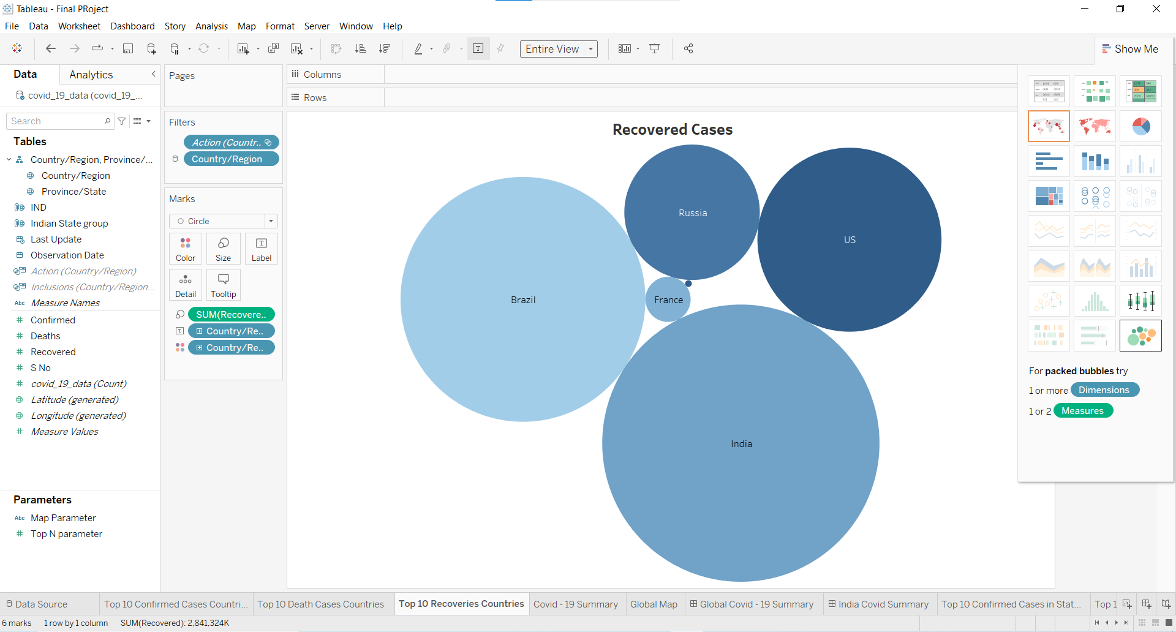
A collection of circles representing data is shown in bubble charts. In contrast to how the values of measure represent the sizes of those circles, each value in the dimension field represents a circle. You can move the necessary fields to various shelves underneath the marks card because the values won't be presented in any row or column. To display data as a collection of circles, use packed bubble charts. Measures specify the size and color of the individual circles, while dimensions specify the individual bubbles. Figure 13 illustrates that the one or more dimensions and one or two measures required for the packed bubbles.

Figure 14
Packed bubbles representing the recovered cases of top 6 nations in the world
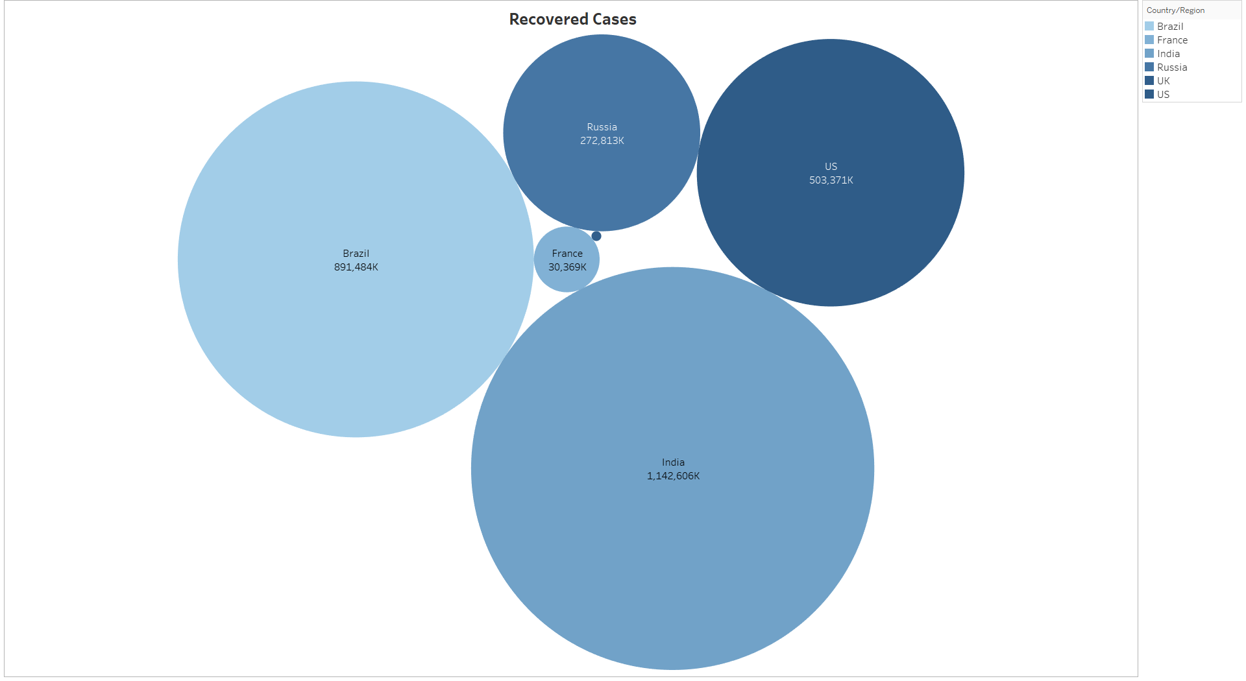
The figure 14 displays the packed bubbles, it displays the recovered cases of top 6 nations in the world. From the figure 14, we can observe that the highest recovered cases by the size of the circles in which India with the 1,142,606K cases then followed by the Brazil with 891,484K cases and the final one was the UK with the 682K cases.

- Summary of the Global Covid - 19 of the entire world
Figure 15
Summary of the global covid – 19 cases
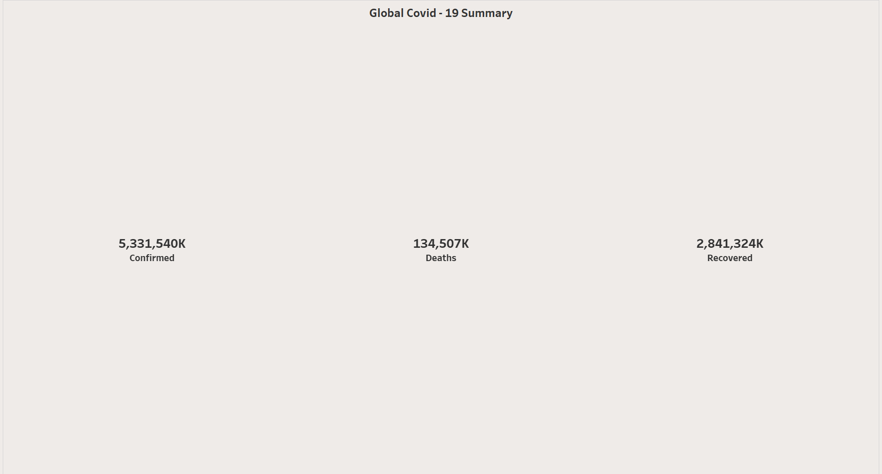
The figure 15 depicts the global covid – 19 cases by considering the measure names and the measure values. Measure Values are taken for the Confirmed cases, deaths and recovered cases and marked it in the filters which displays the numbers and the background color can be changed to the desired colors and the other font and alignment changes can be done as required. This was used in the dashboard to display all the cases values at a glance.

- Summary of the Global Covid - 19 of the entire world
Figure 16
Symbol Maps representing the global map
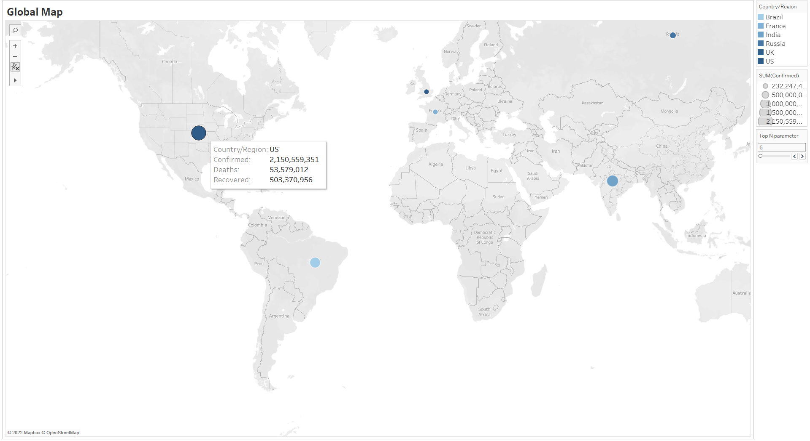
A symbol map makes use of our capacity for information interpretation by symbolically superimposing numerical values over geographic locations. Although they can be any shape of icon, the symbol or symbols on a symbol map are frequently represented by a circle. A data set's values are represented by symbols on the map. These symbols can represent variations in the data by being the same size, shape, and color or by changing (in size, shape, or color). It can be simple to read a map with proportional symbols, and a legend is frequently included. Both the positioning of symbols and their absence can convey meaning. It is possible to use multiple symbols on a symbol map. However, overusing symbols (and combining color, size, and shape into one) can lead to confusion and unnecessary visual complexity. Some symbol maps represent the variable with proportional symbols, so the location may not be precise and overlapping can be seen. Different symbol or color combinations can offer alternatives to proportional symbol maps and may be more effective at leading readers to the right insights.
In the figure 16 represents the global map which shows all the countries confirmed cases, deaths and recovered cases. The Top N Parameter is set to 6 and with the help of slider we can drag and check all the country cases.
- TreeMap for confirmed Cases in India
Figure 17
Top 10 Confirmed Cases in India
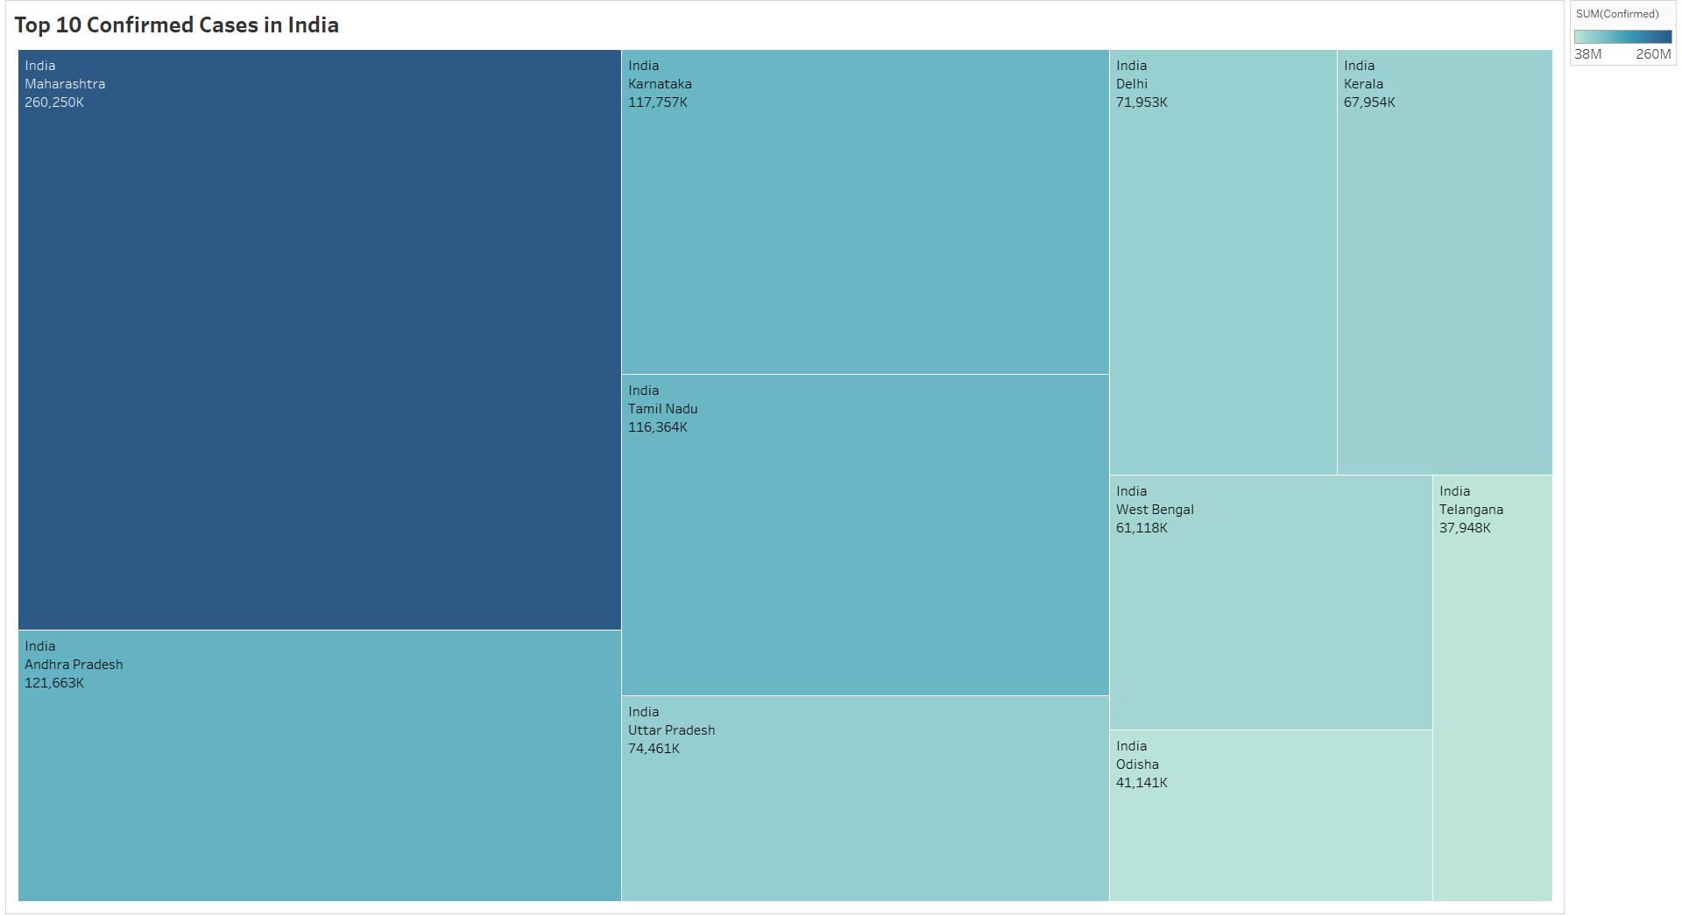
The figure 17, illustrates that the top ten confirmed cases in India whichwas reprsented by the treemap in which the rectangular box and color has the highest of the Maharashtra in 260,250K then followed by the 121,663K Andhra Pradesh and the final was Telangana with the 37,948K cases.
- Vertical bars representing the deaths in states of India
Figure 18
Vertical bars chart
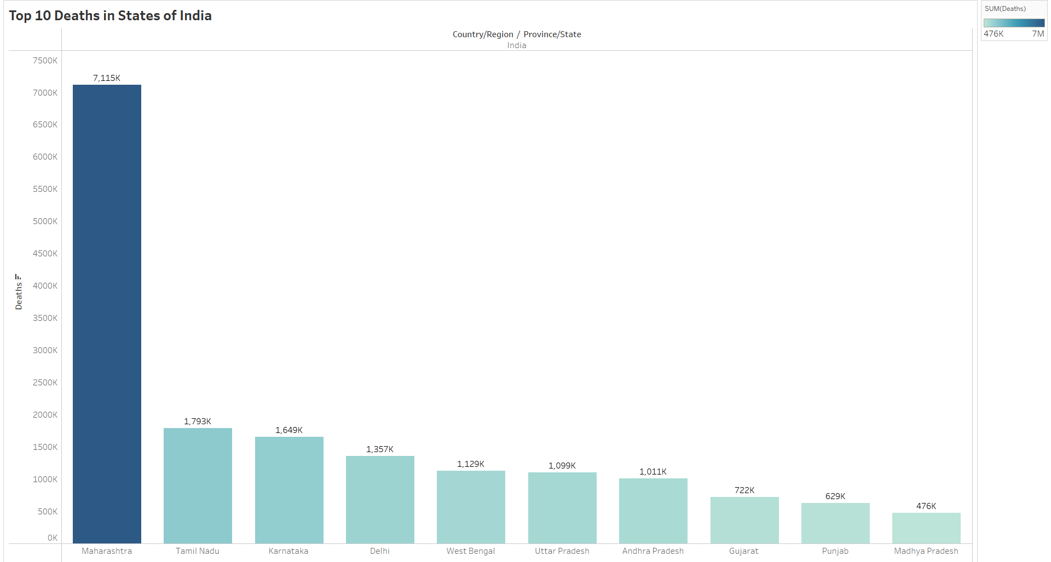
The figure 18 shows the deaths in states of India which has the Maharastra the highest in the deaths with 7,115K and then followed by the TamilNadu the 1,793K and finally the Madhya Pradesh with 476k deaths. The X- axis represents the states of India and the Y-axis represents the deaths.

- Horizontal bars representing the recovered cases in India
Figure 19
Horizontal bars chart
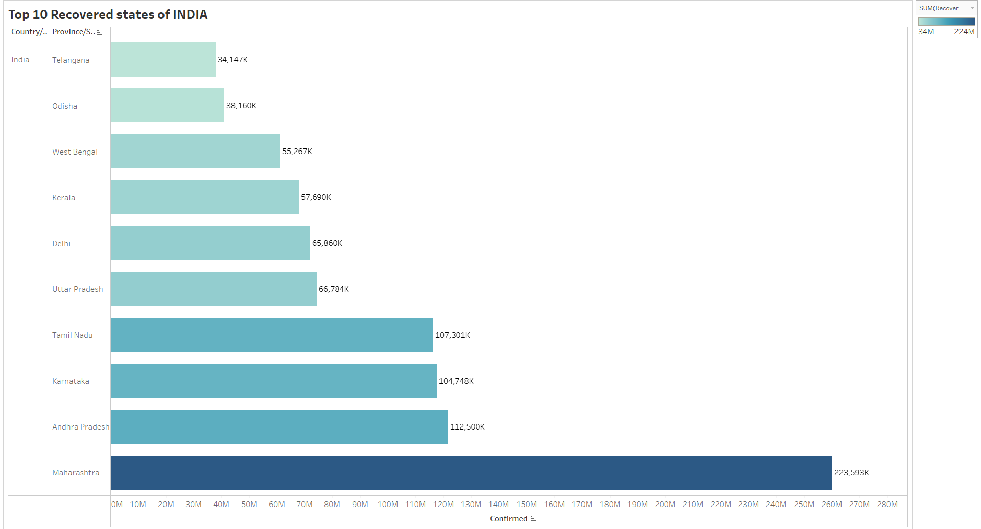
The figure 19 represents recovered cases states of India in which the X – Axis are the cases and the Y – axis are the states of the India in which it was sorted in the ascending order so that the Telagana has the least number of recovered cases that is the 34,147K cases then followed by the Odisha with 38,160K cases and the final was the highest recovered state Maharastra with the 223,593K cases.

DashBoards
Figure 20
Global Covid – 19 Summary Dashboard
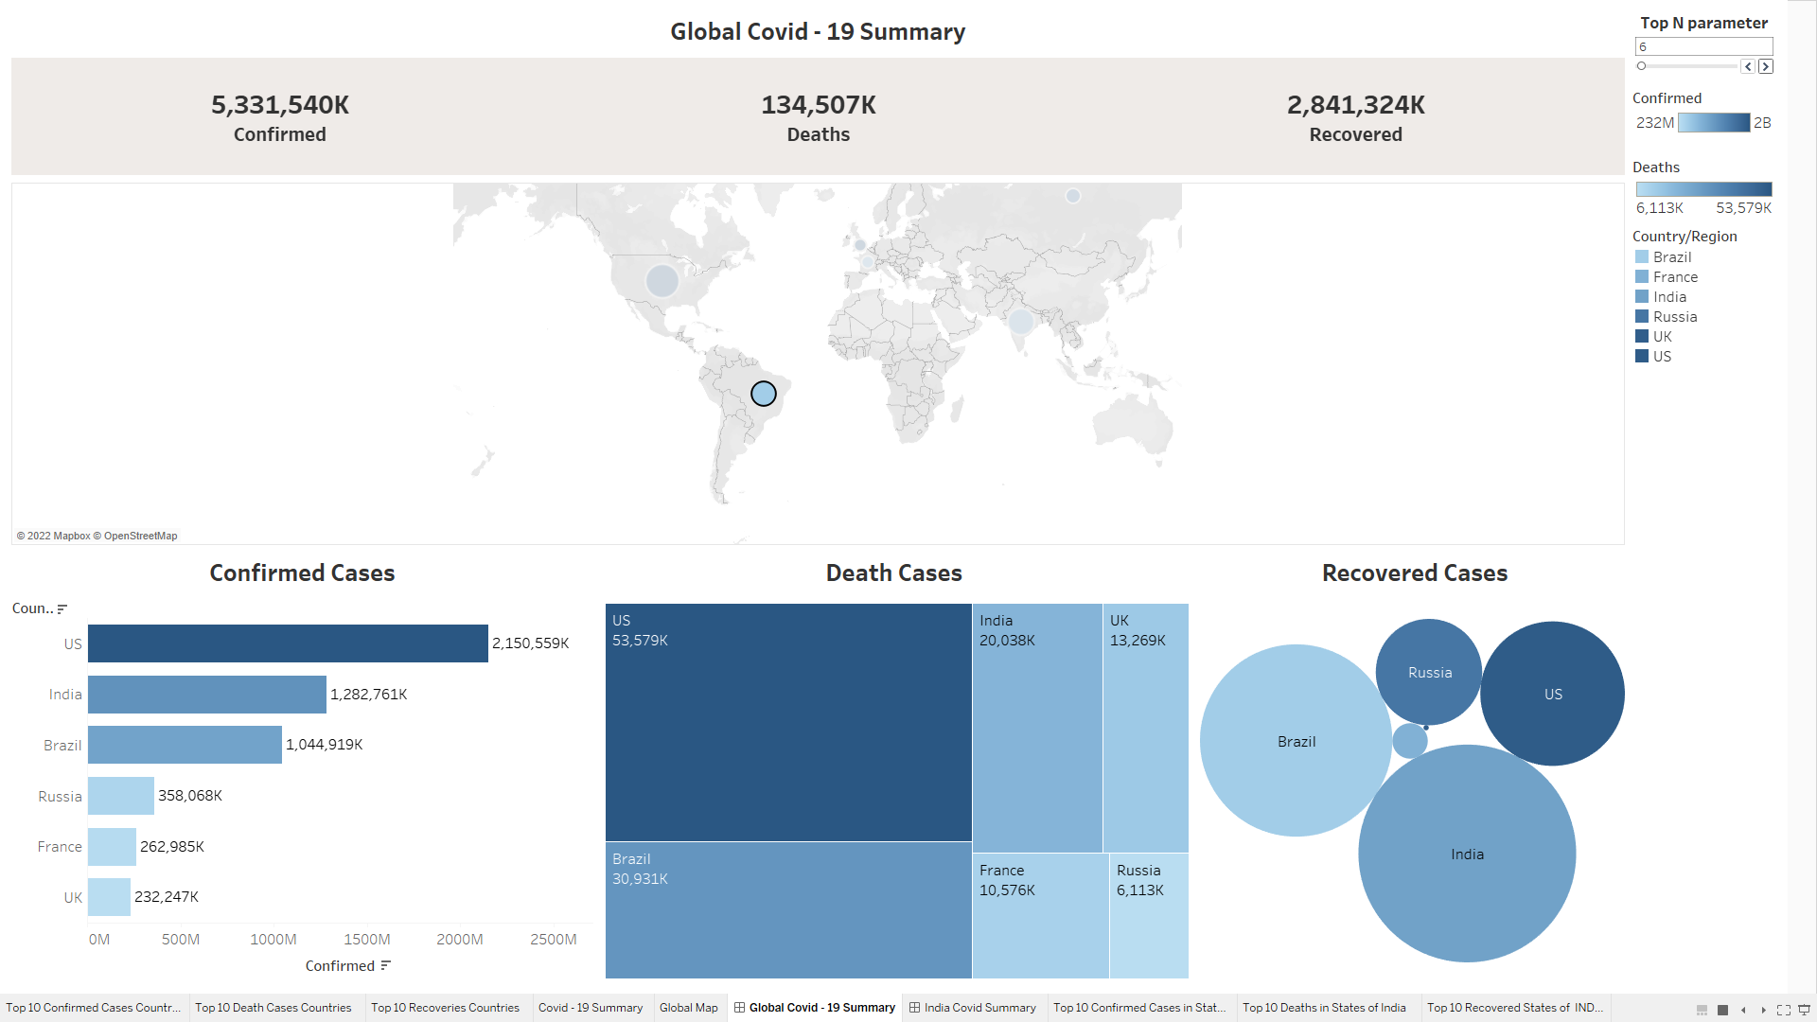
The first dashboard shown in figure 20, was about the overview of the Covid- 19 virus spread over the entire world. It consists of charts for the below mentioned:
- Global Summary representing the number of confirmed, deaths and recovered cases.
- Global Map with countries specifying their respective cases.
- Top N parameter which was set for 6 and shwoing in different charts such as Horizontal, treemaps and packed bubbles respectively.
Country is used as a filter for all of the dashboard's charts because it is an interactive dashboard. We can view all the information and analysis about a particular country by selecting it.

Figure 21
India Covid – 19 Summary Dashboard
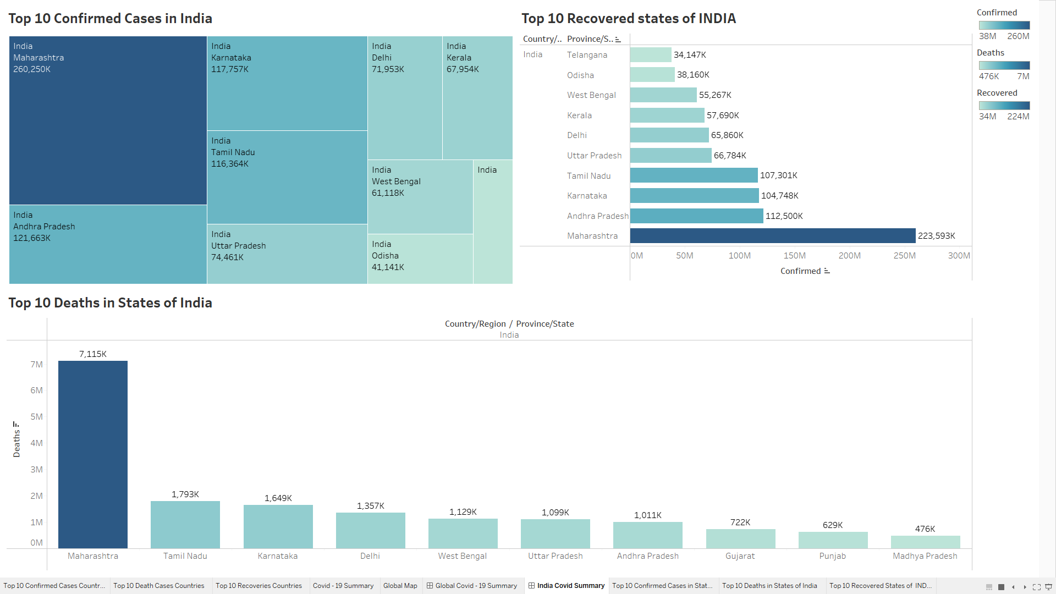
The second dashboard shown in figure 21, was about the overview of the Covid- 19 virus spread over the India. It consists of charts for the below mentioned:
- Top ten states of confirmed cases in India.
- Top ten states of death cases in India.
- Top ten states of recovered cases in India.
- Different charts such as treemaps, horizontal bars and Vertical bars respectively.
Country is used as a filter for all of the dashboard's charts because it is an interactive dashboard. We can view all the information and analysis about a particular country by selecting it.

Conclusion
It was analyzed from the data, the country with the highest probability of confirmed cases is the US and then the Mozambique country having the least probability of confirmed cases. November through February were the most popular months for getting affected because during these months, winter would be at its peak which leads to more chances of cold, cough, throat pain which are symptoms of Covid. India has the highest recovered cases because the vaccination drive started earliest and continued at rapid speed then followed by Brazil. Interestingly, in the India Covid - 19 summary we can predict that Maharashtra was having the highest confirmed cases, highest deaths and highest recovered cases. Weather conditions, no masks, no social distance, no proper hygiene which were one of the main reasons for rise in Covid. However, the implementation of strict lockdowns and increase in vaccination drives in these cases eased the Covid cases and came under control.

Future Scope
In the future, I'd like to examine the World Health Organization's health records (WHO). To understand how WHO improves the lives of people in the global countries, it would be preferable to take into account the status of each beneficiary's project as well as the number of projects that have been completed and the number of people who have benefited from them. Additionally, create a machine learning model using the data from all projects to find anomalies or forecast delays in the project implementation in any of the nations that have obtained WHO credits. Additionally, I want to implement a continuous analysis on a daily basis in the future.

References
https://www.kaggle.com/datasets/sudalairajkumar/novel-corona-virus-2019-dataset
https://gisanddata.maps.arcgis.com/apps/dashboards/bda7594740fd40299423467b48e9ecf6

